- Challenge Name and Category: Scan Surprise (Forensics)
- Difficulty/Points: Easy
- Description: I've gotten bored of handing out flags as text. Wouldn't it be cool if they were an image instead? You can download the challenge files here: challenge.zip
- Flag: picoCTF{p33k_@_b00_0194a007}
- Solution/Walkthrough: Step 1 was download the zip file and take a look inside. Upon opening the final folder there was an image named “flag”.

Opening this image reveals a QR code which contains the flag.

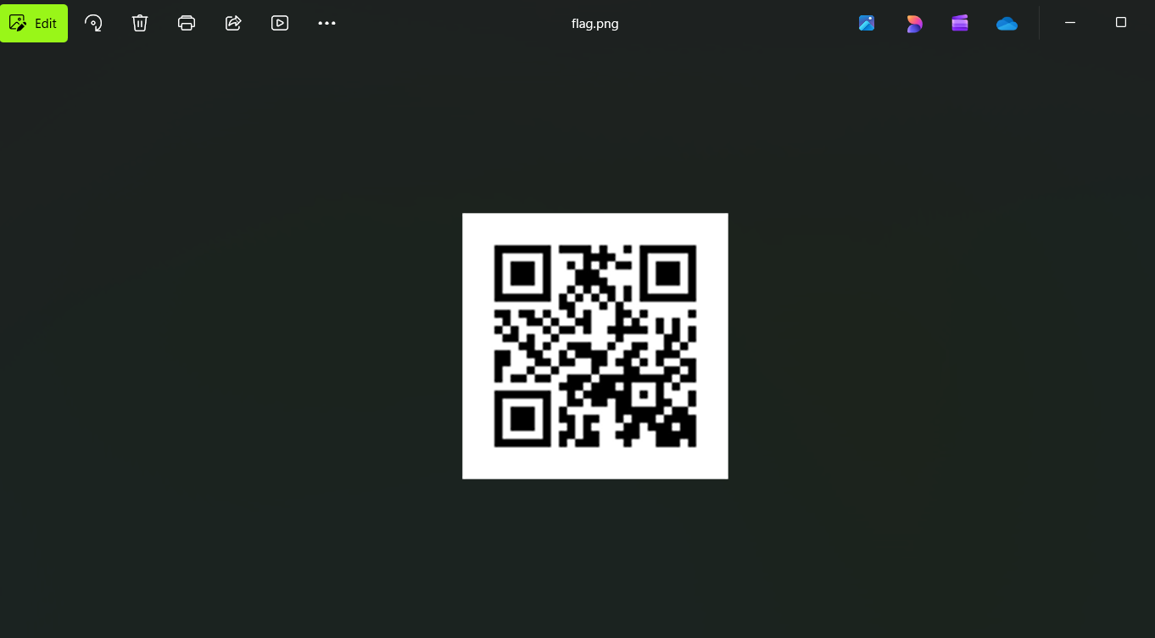 The code can be scanned via your phone or an online scanner like https://scanqr.org/ which is a free to use site that will also display the contents of the QR code.
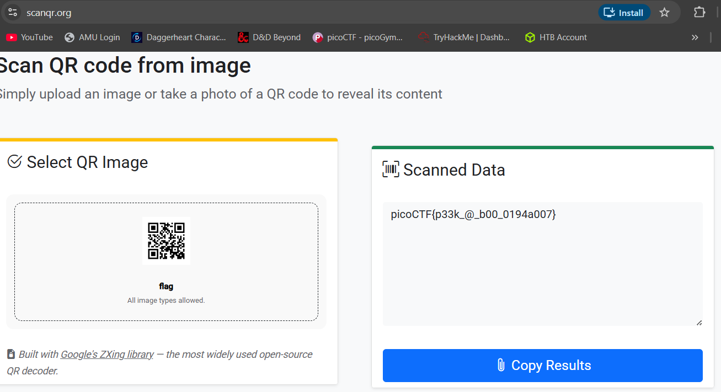
- Tools Used: https://scanqr.org/
- Initial Reconnaissance: The QR code itself is self-explanatory. It’s a very common way to store data.
- Hypothesis Formulation: The flag will be stored in plain text accessible via scanning the QR code. This CTF was a great example of how a QR code works. A Quick Response (QR) code is a two-dimensional, machine-readable barcode that stores digital data (like website URLs, text, or payment info) within a grid of black and white squares. When scanned, the camera interprets the pattern to trigger an action—usually opening a website instantly—making it a versatile tool for quick, contactless data retrieval.
- What Worked vs. What Didn't: N/A

